**Title:**

Nacho Experience(Placeholder)

**Version:**

1.0

**Genre:**

Adventure/Side Scroller

**Platform:**

PC (Only?)

**The Big Idea:**

The idea is based on a real-life person name “Nocho” on being homesick and dealing with the “red tape” of not being able to travel back home. This fictional character will receive text messages/phone call from the family back home (different country) and needs to go out of his house and explore Chicago where he needs to find things that reminds him back home.

 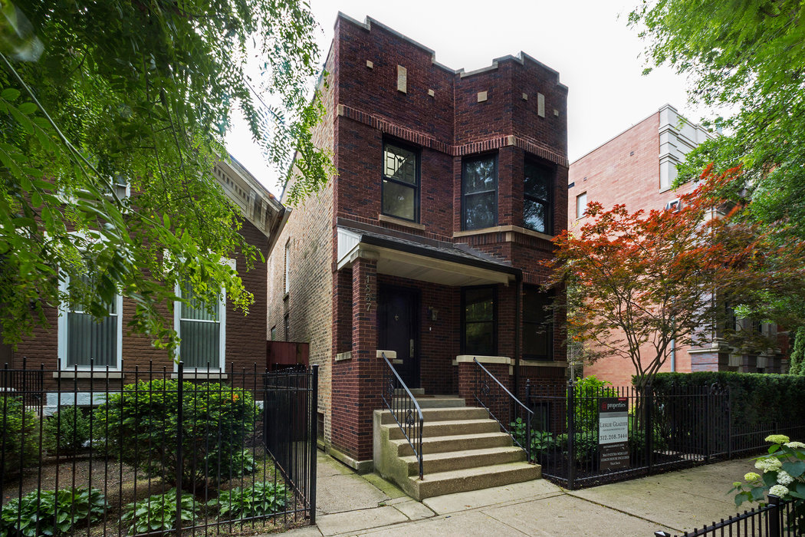

**Theme:**

The Game Jam theme is “What Home Means To You?”Focusing on the meaning of the idea of what really makes a home and making it your own.

**Category:**

Nacho Experience (Placeholder) is a 2D adventure/side scroller where the player needs to find things that remind the main character (MC) about back home in his own country. The game world starts out in black & white (the perspective of the MC) but over time, the color of the world around the MC comes back to life! Each day (4 days), there is a new puzzle to solve by going out of the house and find things that the main character be able to take home. Each time the player finds and returns it back home (placing it in the room of the home), more and more of the color of the world comes back!

**Key Features/Game Mechanics:**

* The gameplay will be similar to a game called *Night in the Woods,* where the player walks around and explore the city and is able to interact the world around the MC. Maybe include some platforming sequences depending on the puzzle?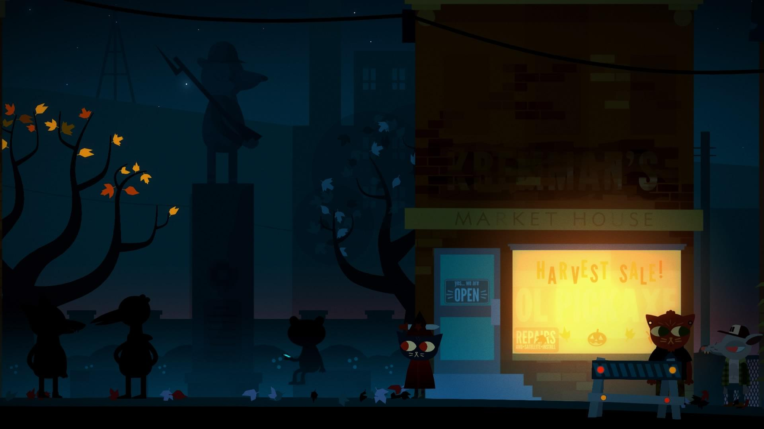



* The whole game takes place in one long frame (one level), where the player starts out in the house on each day.
* Each day, the player needs to solve a puzzle and place it in the room. Each time the player place an object in the room, that room color comes back. This gives the player a sense of progression.
* The object glows with color when it’s in view of the player

**Artwork:**

* Main Character

|  |  |  |
| --- | --- | --- |
| * + Standing   + Thinking pose (When the thought bubble comes up) | * + Walk cycle | * + Interacting things(Character hand sticks out) |

* Thought bubble
  + 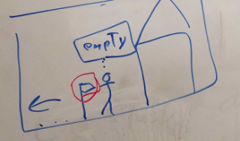
* Rooms of the house

|  |  |  |  |
| --- | --- | --- | --- |
| * + Living Room | * + Kitchen | * + Bedroom | * + Music Room |

* City Skyline in the background
* House Door opening
  + 
* Threes
* Mailbox
* Cars
* Male and Female of Silhouette of people walking around the streets
* Underground subway
* A cat
* Shop buildings
* Street
* Signs
* Street lights?

**Music/Sounds:**

* Main character
  + Footsteps
  + When the player interacts objects
  + Sound when the character goes into a thinking pose
* Cellphone
  + When ringing
  + When getting a text message
* Mailbox opening
* Door opening
* Jazz Music
* Cat sound
* Cars
  + Passing by.
  + Traffic/birds ambient noise/sounds
* Music when the intro texts comes up?
* Subway sounds
  + Train passing by
  + Ambient subway noises
  + Speakers relaying information but it will just be robotic/radio gibberish